**The Truman Show**

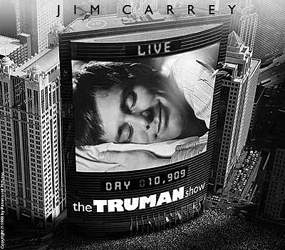

Truman Burbank is a normal man, living in a normal town. He grew up to be a desk clerk for a insurance company, living an ordinary life, having an ordinary wife, an ordinary neighbor and an ordinary bud, who pops in from time to time with a six-pack. But Truman is not happy with his life. He wants to see the world. He wants to get away from his happy-happy, ever tidy, nice’ n’ shiny little island town at the seaside. In reality, Truman was an unwanted pregnancy. His “father”, Christof, a reckless TV-Producer whom he never met, made up the Truman Show - the greatest show on earth - a show in which life is live. So, everyone around poor Truman is an actor with a little headphone in the ear. One day, Truman accidentally bumps into a catering area backstage and gets pretty suspicious.

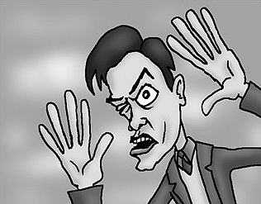

Directed by.... Peter Weir

Jim Carrey.... Truman Burbank

Ed Harris.... Christof

Laura Linney.... Meryl Burbank/Hannah Gill

Noah Emmerich.... Marlon/Louis Coltrane

Natascha McElhone.... Lauren Garland/Sylvia

Holland Taylor.... Truman’s Mother

**Previewing Prompt**

How much privacy should an individual have in today’s world. For example, should we have cameras at intersections to catch those who run red lights? Should all convenience stores have cameras to observe people who enter? Should records be kept on the internet to record where you have been and what you have done? For our safety, how much should we observe our neighbors behavior. Discuss.

______________________________________________________________________  
______________________________________________________________________

______________________________________________________________________ ______________________________________________________________________ ______________________________________________________________________

______________________________________________________________________  
______________________________________________________________________

______________________________________________________________________ ______________________________________________________________________ ______________________________________________________________________

______________________________________________________________________  
______________________________________________________________________

______________________________________________________________________ ______________________________________________________________________ ______________________________________________________________________

______________________________________________________________________  
______________________________________________________________________

______________________________________________________________________ ______________________________________________________________________ ______________________________________________________________________

**Double Entry Journal**

Below is a double entry journal. In the *left* column, you will describe scenes from the film that seem intriguing, interesting, or relate to your life in some way. In the *right* column, you will write your responses to the scenes you have selected. Your responses might indicate what the scene means, what it reminds you of, what you don't understand, how you feel about it, or any other comments that seem appropriate.

|  |  |
| --- | --- |
| **Scenes** | **Responses** |
|  |  |
|  |  |
|  |  |
|  |  |
|  |  |

**Double Entry Journal**

Below is a double entry journal. In the *left* column, you will describe scenes from the film that seem intriguing, interesting, or relate to your life in some way. In the *right* column, you will write your responses to the scenes you have selected. Your responses might indicate what the scene means, what it reminds you of, what you don't understand, how you feel about it, or any other comments that seem appropriate.

|  |  |
| --- | --- |
| **Scenes** | **Responses** |
|  | Product Placement – The purpose of this scene was to… |
|  | Anger – This scene angered me because… |
|  | Surprise – This scene surprised me because… |
|  | Connection – This scene reminds me of… |
|  | Criticism – I would change this scene by … |

**Venn Diagram**

*The Truman Show* has been compared by critics to a fifties sitcom. America in the 50s and Truman’s life were very similar. Both were out of balance and had forces of discontent. First, look at the fifties, then at Truman’s life. Compare and contrast the two.

**America in the Fifties The Truman Show**

**The Hero’s Escape**

|  |  |
| --- | --- |
| **The Events** | **The Scenes** |
| Many stories begin by showing us characters who are happy in their artificialworlds. |  |
| Things begin to happen that challenge the characters’ acceptance of their surroundings. |  |
| A process of recognition sets in, in which the characters begin to realize they are prisoners. What they thought was the world begins to look like a cage. What they thought was a life begins to look like a lie. |  |
| In the next phase in the story, the characters try to make their escape. But it turns out there is a malevolent simulator who is responsible for trapping them inside this fraud, and he, she, or it tries to make it impossible for them to leave or be free. |  |
| The characters must overcome both fears in themselves and the external obstacles put in their way by these futuristic prison keepers to finally be free. |  |
| In the end, they escape and discover the world they had been isolated from. Their new home has at least three essential characteristics: it isn’t controlled by others; it allows them to see things as they are, and it allows them to become their true selves |  |

**Literary Terms**

Provide examples of the terms below as they appeared in the movie *The Truman Show.*

**conflict, climax, irony, inciting incident, symbolism, flashback**

1. What was the climax of the film? Defend your answer.

______________________________________________________________________  
______________________________________________________________________

______________________________________________________________________ ______________________________________________________________________

2. Were there any flashbacks or flash forwards in the film? If so, were they used effectively? Explain.

______________________________________________________________________  
______________________________________________________________________

______________________________________________________________________ ______________________________________________________________________

3. What is the inciting incident of this film? Defend your answer.

______________________________________________________________________  
______________________________________________________________________

______________________________________________________________________ ______________________________________________________________________

4. Choose a scene or event that was ironic. Explain.

______________________________________________________________________  
______________________________________________________________________

______________________________________________________________________ ______________________________________________________________________

5. Was there an example of a metaphor in this film?

______________________________________________________________________  
______________________________________________________________________

______________________________________________________________________ ______________________________________________________________________

**Open Mind**

Pretend you are able to see into the minds of these two characters in order to discover who they really are. In each mind include the following: 2 actions, 2 quotes, a physical description, a color that correctly symbolizes them, and 2 personality traits.

**Truman Burbank Christoff**

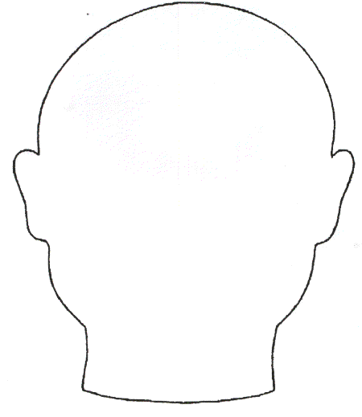

Analysis

1. What is the theme of this film? Explain.

______________________________________________________________________  
______________________________________________________________________

______________________________________________________________________ ______________________________________________________________________ ______________________________________________________________________

2. Discuss the significance and symbolism of the following names used in the film.

a. Truman

______________________________________________________________________ ______________________________________________________________________ ______________________________________________________________________

b. Burbank

______________________________________________________________________ ______________________________________________________________________ ______________________________________________________________________

c. Christof

______________________________________________________________________ ______________________________________________________________________ ______________________________________________________________________

d. Seahaven

______________________________________________________________________ ______________________________________________________________________ ______________________________________________________________________

3. How does the film view the following themes/ideas?

a. Truth

______________________________________________________________________ ______________________________________________________________________ ______________________________________________________________________

b. Freedom

______________________________________________________________________ ______________________________________________________________________ ______________________________________________________________________

c. Love

______________________________________________________________________ ______________________________________________________________________ ______________________________________________________________________

d. Perfection

______________________________________________________________________ ______________________________________________________________________ ______________________________________________________________________

e. Relationships

______________________________________________________________________ ______________________________________________________________________ ______________________________________________________________________

4. Some people today believe that, like in the Truman Show, the media and large corporations have begun to script and stage-manage our world. Surveillance cameras are everywhere; the internet leaves a record of where we’ve been and what are our preferences; our credit history is for sale; our news is filtered through television; we only see what the large corporations that own the stations allow us to see. In this respect, The Truman Show is a metaphor for the false society that we mistake for the real world. Write a response in which you explain your views on privacy and the dangers you feel (or do not feel) are posed by technology and media. How far will it go? What do you see in the 21st century?

______________________________________________________________________  
______________________________________________________________________

______________________________________________________________________ ______________________________________________________________________ ______________________________________________________________________

____________________________________________________________________________________________________________________________________________ ______________________________________________________________________

Partner Projects

1. Imagine a new product to be placed into “The Truman Show” (shoes, hair products, perfume or cologne, medicines, automobiles, etc). Where would you place your product? How would you get viewers to notice their item? (One of Meryl’s speeches? A large poster? A character using it?)

______________________________________________________________________  
______________________________________________________________________

______________________________________________________________________ ______________________________________________________________________ ______________________________________________________________________

____________________________________________________________________________________________________________________________________________

1. Imagine and write an alternative ending to the film.

______________________________________________________________________  
______________________________________________________________________

______________________________________________________________________ ______________________________________________________________________ ______________________________________________________________________

____________________________________________________________________________________________________________________________________________ ______________________________________________________________________

______________________________________________________________________  
______________________________________________________________________

1. Think about and explain why you altered the ending as they did. Who did you punish, if anyone? Who, if anyone, “wins”? What do you think your choices say about your own sense of reality?

____________________________________________________________________________________________________________________________________________ ______________________________________________________________________

______________________________________________________________________  
____________________________________________________________________________________________________________________________________________

Fun Facts

* Joel Gold, a psychiatrist at the Bellevue Hospital Center, revealed that by 2008, he had met five patients with schizophrenia (and heard of another twelve) who believed their lives were reality television shows. Gold named the syndrome "The Truman Show Delusion" after the film and attributed the delusion to a world that had become hungry for publicity. Gold stated that some patients were rendered happy by their disease, while "others were tormented". One traveled to New York to check whether the World Trade Center had actually fallen — believing 9/11 to be an elaborate plot twist in his personal storyline. Another came to climb the Statue of Liberty, believing that he'd be reunited with his high-school girlfriend at the top and finally be released from the show.
* People on the set were forbidden from uttering phrases from Jim Carrey's past "silly" movies.

* The name of Truman's sailboat is the Santa Maria, the same name as one of Christopher Columbus's ships.
* The motto on the double archway in the Seahaven town center is UNUS PRO OMNIBUS, OMNES PRO UNO: "One for all, all for one" in Latin, thus fitting the premise of the Truman Show. The motto is also the used in the Alexandre Dumas père's novel, The Three Musketeers.
* Just before the boat stops, we see the number "139" prominently displayed on its sail. The ensuing dialogue between Truman and Christof contains some paraphrased references to Psalm 139, as do many other aspects of the film.
* The Trumania bit, where Jim Carrey draws on the mirror with soap and acts strange, was completely improvised by Carrey. In another take he drew long curly hair and a dress.
* The ending mirrors the ending of the C.S. Lewis book "Voyage of the Dawn Treader", #4 of the Narnia series (#3 in publication order), with a ship sailing to the end of the "known" world and encountering a sky-blue wall, with a doorway leading to "another" world.

Choose one Fun Fact and respond to it.

________________________________________________________________________________________________________________________________________________________________________________________________________________________________________________________________________________________________________________________